Answers of Example Questions for Midterm Exam

Part 1: Data Preparation before Data Mining

1-
Dataset: 6, 7, 8, 18, 20, 22, 26, 27, 28, 30, 31, 32

(32-6) / 3 = 8.6

[6 - 14]
[15 -23]
[24 - 32]

• Partition into equal-width bins:  - Bin 1: 6, 7, 8  - Bin 2: 18, 20, 22  - Bin 3: 26, 27, 28, 30, 31, 32 | • Smoothing by bin means:  - Bin 1: 7, 7, 7  - Bin 2: 20, 20, 20  - Bin 3: 29, 29, 29, 29, 29, 29 | • Smoothing by bin boundaries:  - Bin 1: 6, 6, 8  - Bin 2: 18, 18, 22  - Bin 3: 26, 26, 26, 32, 32, 32
• Partition into equal-depth bins:  - Bin 1: 6, 7, 8, 18  - Bin 2: 20, 22, 26, 27  - Bin 3: 28, 30, 31, 32 | • Smoothing by bin means:  - Bin 1: 10, 10, 10, 10  - Bin 2: 24, 24, 24, 24  - Bin 3: 30, 30, 30, 30 | • Smoothing by bin boundaries:  - Bin 1: 6, 6, 6, 18  - Bin 2: 20, 20, 27, 27  - Bin 3: 28, 28, 32, 32

2-
13, 15, 16, 16, 19, 20, 20, 21, 22, 22, 25, 25, 25, 25, 30, 33, 33, 35, 35, 35, 35, 36, 40, 45, 46, 52, 70.

a) norm(x) = x-13/(70-13) (1-0) + 0 = 22/57 = 0.39
b) norm(x) = (x-avg) / sdev = (35 - 30) / 13 = 0.38
c) norm(x) = x/100 = .35
d) write your own comments

3-
( 82 – 10 ) / 4 = 72 / 4 = 18

[10 – 28]
(28 – 46]
(46 – 64]
(64 – 82]

Replace old age values with new ones.

4- Five techniques:
- Global Constant
- Most Repeated Value
- Mean
- Conditioned mean
- Most probable value

5-
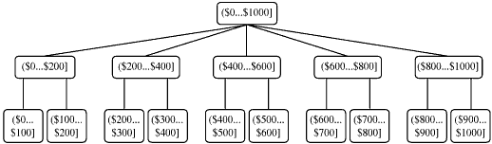

Product ID | Product Name | Category | Price ($)
1001 | Apple TV | Gadgets | 200..400
1002 | iMac | Desktop Computers | 800..1000
1003 | iTouch | Gadgets | 0..200
1004 | Wii | Gaming | 400..600
1005 | Time Capsule | Acessories | 400..600
1006 | MacBook Pro | Mobile PC | 600..800
1007 | iPhone | Mobile | 600..800

6-
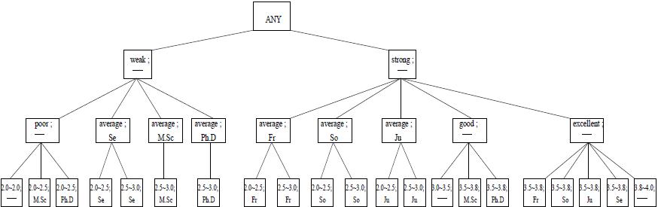

Student ID | Student Name | Status | GPA
20071001 | Ali Taş | Junior | Strong
20071002 | Ayşe Kaya | Fresman | …
20081003 | Fatma Gül | PhD | …
20081004 | Sibel Yılmaz | MSc | …
20081005 | Mehmet Bilge | Sophomore | …
20091006 | Mustafa Yeşil | Senior | …
20091007 | Sinan Ak | PhD | …

7- Data Reduction Strategies
1- Data Aggregation
2- Dimensionality Reduction
3- Data Compression
4- Sampling
5- Clustering
6- Concept hierarchy generation

Part 2: Association Rule Mining in Data Mining
8-
Candidate 1-Itemsets
- Spaghetti → support = 3 = 60%
- Tomato Sauce → support = 3 = 60%
- Cola → support = 4 = 80%
- Butter → support = 1 = 20%

Candidate 2-Itemsets
- {Spaghetti, Tomato Sauce} → support = 2 = 40%
- {Spaghetti, Cola} → support = 2 = 40%
- {Tomato Sauce, Cola} → support = 2 = 40%

Candidate 3-Itemsets
- {Spaghetti, Tomato Sauce,Cola } → support = 1 = 20%

Rule: If Spaghetti then Tomato Sauce
Support: s = 2 / 5 = 0,4 = 40%
Confidence: c = 2 / 3 ≈ 0,66 = 66%

Rule: If Spaghetti then cola
Support: s = 2 / 5 = 0,4 = 40%
Confidence: c = 2 / 3 ≈ 0,66 = 66%

9-
{D H} 4/16
{B E} 5/16
{G H} 5/16
Min (4/16, 5/16, 5/16) = 4/16

10-

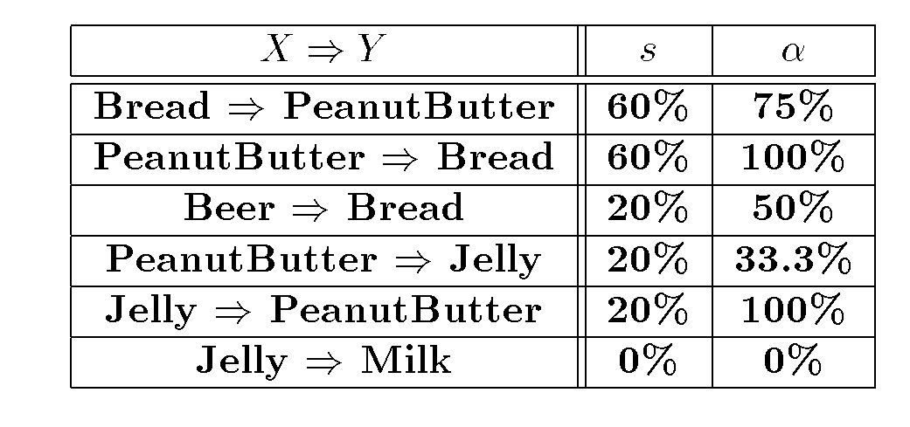

11-
12-

Part 3: Sequential Pattern Mining
13-
Data Sequence | Subsequence | Contain?
<{2,4}{3,5}{4,7}{4,5}{8}> | <{4,7}{8}{3,5}> | No
<{1}{2,3}{4}{5,6}> | <{2}{4,5}> | No
<{1}{2,3}{3,4}{4,5}> | <{2}{3}{4}> | Yes
<{1,2}{3}{2,3}{3,4}{2,4}{4,5}> | <{3,2}{3}{2}{5}> | Yes
<{1}{2,3}{4}{5,6}> | <{1}{2,3}{4}{5,6}> | No

14-
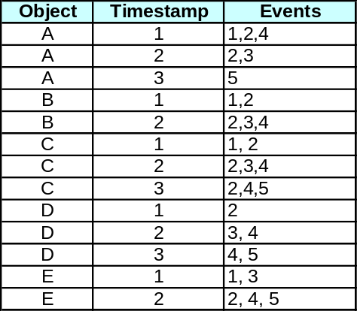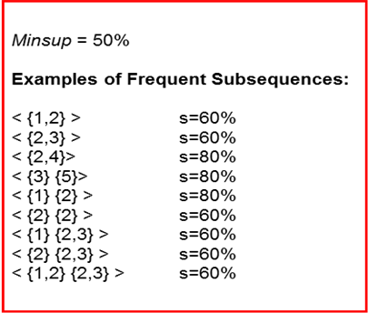

15- ⟨(1, 4, 5)(7)(4, 5)(3, 8)⟩

Items = {1, 3, 4, 5, 7, 8}
Size = 4
Length =8

16- ⟨(7)(4, 5)(3)⟩
(7)
(4)
(5)
(3)
(7)(4)
(7)(5)
(7)(3)
(7)(4,5)
(7)(4)(3)
(7)(5)(3)
(4,5)
(4,5)(3)
(4)(3)
(5)(3)

17- What is the support of the sequence <(3)(9)(4)(6)>
Sequences
<(7)(3,8)(9)(4,5,6)(8)>
<(8)(3,8)(9)(4,5)(6)(7)>
<(3)(5,4)>
<(3)(5,4)(6)(9,8)>
<(10)(3)(9,8)(5,4)(6,8)>
<(3,4)(6,6)(9,8)>
<(3)(9)(5,4)(6)(9,8)>
<(3)(5)(4)(6)(9,8)>
<(3)(9)(5,2,1)(4,6)(9,8)>
<(3)(9)(6)(4,6)>

3/10

Part 4: Classification Techniques in Data Mining
19-
InformationGain(age) = ..... √
InformationGain(competition) = .....
InformationGain(type) = .....

InformationGain(age_{mid},competition) = ..... √
InformationGain(age_{mid},type) = .....

= -(1/2) (-1) - (1/2) (-1)
= 1/2+1/2
= 1

log₂1/2=-1
log₂1=0

= 1- 3/10 (-3/3 log2 3/3) - 3/10 (-2/3 log2 2/3-1/3 log2 1/3) – 4/10 (-4/4 log2 4/4)
= 1- 0 - 3/10 * ( 0.38 + 0.52) - 0
= 1 - 0 - 3/10 * 0.9 - 0
= 1- 0 - 0.27 - 0
=0.73

-3/3 log2 3/3 = 0
log₂ 1 =0

Gain(S, Competition) = 1- 4/10 (-1/4 log2 1/4 – 3/4 log2 3/4) – 6/10 (-2/6 log2 2/6 – 4/6 log2 4/6)
= 1- 4/10 (0.5 + 0.31)
= 1- 0.4 * 0.8
= 1- 0.32
=0.68

log₂ 0.5 = -1
log₂ 0.1 = -3.3
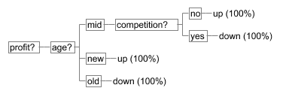

20-
InformationGain(savings) = ..... √
InformationGain(assets) = .....
InformationGain(income) = .....

InformationGain(savings_{low},assets) = ..... √
InformationGain(savings_{low},income) = .....

InformationGain(savings_{high},assets) = .....
InformationGain(savings_{high},income) = ..... √

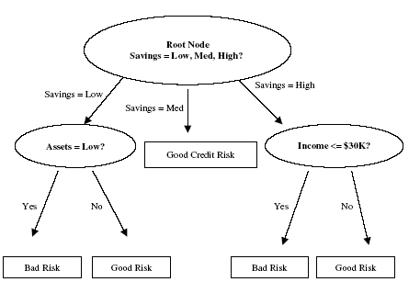

21- The entropy of IsHeavy and IsSmelly are equal to log(2). Lets examine the entropy for IsHeavy. There are 2 instances where the IsHeavy is equal to 0, namely A and B. IsPoisonous has 0 and 1 respectively. So, each class, 0 and 1, has same probability split is log2. For the IsHeavy equals to 1 case, C and D, this is also the case so entropy of the IsHeavy is equal to: ½*log(2)+ ½*log(2) = log(2).

The entropy of IsSpotted is less than log2 so the root has the attribute isSpotted.
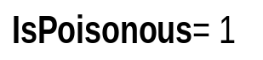
IsSpotted
1
0
There is only one case where IsSpotted is 1, B. For the cases IsSpotted equals to 0 the entropy of the other two attributes are equal to each other, so anyone can be selected as the second attribute. I selected IsHeavy. For the cases where IsSpotted is 0 and isHeavy is 1 we need IsSmelly. The resulting decision tree:

IsPoisonous= 1
IsSpotted
1
0
IsHeavy
1
0
IsSmelly
1
0
IsPoisonous= 0
IsPoisonous= 1
IsPoisonous= 0

The predictions for E, F, G, and H are as follows:
The IsSpotted is equal to 1 for E, F, and H hence the prediction is 1 for them. For G IsHeavy is 0 so, the prediction is 0.

E→ 1, F→ 1, G→0, and H→1

The Boolean equation is IsHeavy XOR IsSmelly = IsPoisonous

22- Conditional Probabilites
Consider this statistical summary of the weather data set.
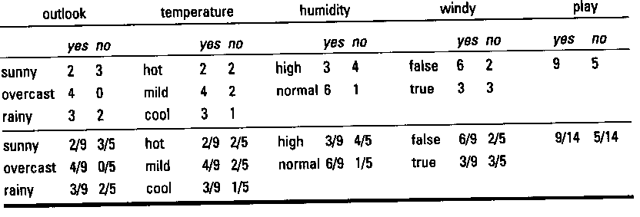
Now assume that the attributes outlook, temperature, humidity and windy are,
- independent of one another,
- equally important (have equal weight).
Because of these assumed characteristics we can calculate probabilities in the follwoing simple ways.
[outlook=sunny, temp=cool, humidity=high,windy=true]
- Likelyhood(play = yes) = 2/9 * 3/9 * 3/9 * * 3/9 * 9/14 = 0.0053
- Likelyhood(play=no) = 3/5 * 1/5 * 4/5 * 3/5 * 5/14 = 0.0206
To change these likelyhoods into probabilities we must normalize so that the probabilities sum ot 1 (or 100%).
- Pr(play = yes) = 0.0053 / (0.0053 + 0.0206) = 0.205
- Pr(play = no) = 0.0206 / (0.053 + 0.206) = 0.795
No play will take place

23- Triangle

24- Euclidean Distance(doc_new, doc1) = ….
Euclidean Distance(doc_new, doc2) = ….
Euclidean Distance(doc_new, doc3) = ….

Select minimum

